LESSON WISE ACTIVITY PLAN (PRIMARY)
Class / section : _V/D Subject : English Lesson / Topic : Rip Van Winkle
No. of Periods required : 08, Date of Commencement -1st.Sept.2014, Expected Date of Completion : 30th.Sept.2014,
Actual Date of Completion : 30th.Sept.2014
Competency Wise Expected Learning Outcome | Activities  Individual / Group | Role Definition |  | Resource  Aids / TLM
Competency Wise Expected Learning Outcome | Activities  Individual / Group | Teacher | Student | Resource  Aids / TLM
1..Reading: Children will learn the importance and the proper application of punctuation, modulation, intonation, gesture, posture and the pronunciation along with the value of reading a topic with correct procedure. So the interest will be created in the mind of the children to inculcate good reading habits. | ACTIVITY-1. Introduction of the topic will be taken up through the recapitulation of the previous lesson and introduce the children to the topic with curiosity. | In this column the teacher will put some easy and interesting questions and create a curiosity in the class to reach the topic.  1.Who was lolling all the days on the log? 2.What is the name of lazy frog? | Children will maintain discipline and raise hands for their better  Participation.  Exp.Ans 1..A lazy frog  2.It is Fred | Text Book  Flash Cards  Picture Flash Cards  Dictionary  Activity Sheet
2.Listening: Children will realize that a good listener understands the concept well and acquires good knowledge which he reproduce the matter in a better way. So the curiosity will be created among the children to listen the topic well and to respond with full enthusiasm. | ACTIVITY-2. The teacher will go with the model reading of the story of the text and the whole children will observe the reading of the teacher attentively | The teacher will ask the children to open the page No. and to observe that how he reads the lesson. In this he will read the text aloud along with necessary punctuations, modulations, intonations, gestures, and postures with proper pronunciation. | Here children are expected to extend full co-operation by observing the complete reading activities of the teacher and to follow them sincerely. | PPT  Smart Board  Work Sheet  And some of the following pictures and models.
3.Speaking: Speaking improves the level of confidence and moves the person a step ahead. So all the children will be encouraged to take active participation and to speak something about the lesson through which they can enhance their confidence level better. | . ACTIVITY-3 Some of the bright and slow achievers will be asked to go with the individual loud reading by following all the punctuations and the other necessary reading activities. Then the entire class will read the lesson silently and find out the new words for clarifications. | In this stage teacher is suppose to encourage the bright students and help the slow achievers whenever they need. He should also supervise the silent reading activities and on the finding of new words. | Children are expected to observe the correct reading of their peer group. They will under line all the new words in pencil to get them clarify. | 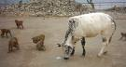
4.Writing: As practice makes man perfect writing is one of the best ways to get practice | ACTIVITY-4 New words will be drilled through some simple and easiest sentences with meanings and all the students must note down them. | For the clarification of new words teacher should involve the maximum number of students. Slow achievers should be given due weightage and the brights must be praised. Writing work should be supervised keenly. | High achievers: Find the meanings of the new words and make sentences of their own. Slow achievers: Read the given words in flash card and make simple sentences. | 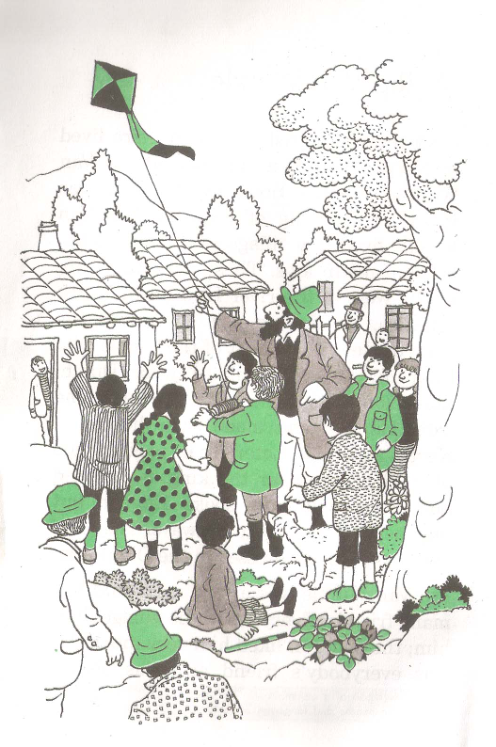
5. ELO of the Lesson : Along with the new words and grammar exercises children will realize the theme of the lesson that work is worship and laziness is curse because laziness keeps away all the good qualities and ruins the life. | ACTIVITY-5 The details of the lesson will be explained thoroughly with all its meanings, grammatical words, theme, and the exercise of the lesson.. The slow achievers will be taken very special care during all the activities in the class and the bright students will be encouraged for higher achievements. | Maintenance of discipline and the complete involvement of the class should be the aim of the teacher. He should ensure that all the written works are taken up properly and necessary TLMs are used in proper time. | Interact actively in the discussion. They will complete the spelling of the given words, make words from the jumble letters, make use of describing words (good natured, high heeled, lazy, etc.,), making plural forms, make use of adverbs (rarely, usually, frequently) and they will note down all the exercise works. |   

Recapitulation Strategy : At the end the entire grammar portions ,new words and the theme of the lesson will be taken up through different activities.
Correlation with other Subjects : Social behaviour , Psychology, Irresponsibility, Games etc.,
Value : Laziness is a disease which becomes a curse and takes away all other good qualities in man.
Evaluation and Feedback : A work sheet will be given with all the values of positive attitude and the work oriented nature of a person.

Signature of Teacher with date: Signature of HM/Vice Principal/Principal:

